**RUCKUS TQA**

Bayley Fisher

Blake Andrews

Brian McNamee

Stan Katunin

**Version History**

|  |  |  |  |
| --- | --- | --- | --- |
| Date | Version | Notes | Member |
| 9/9/23 | V.1 | * Basic layout. | Blake |
| 13/9/23 | V.1.2 | * Formatting solidified. * Version history added. * Table of contents added. * Milestones added. * Phases added. * Testing Methods added. * Excel forum. | Stan/Blake/Brian |

**Contents**

Introduction & Overview

Dev & Client Goals

Milestones

Testing Overview

Testing Techniques

Phases

TQA Form

Identification of Testing Methods

Identification of Data Collected

**Introduction & Overview**

**RUCKUS** has just entered beta! The current plan for the project is to **beta test**! We are developing a test plan to essentially go over the bugs in the game and make it the smoothest possible experience for our players – so there is no disparity in the gameplay and mechanics.

**Developer & Client Goals**

*Gameplay*

Augments, clean fluid movement of the character. Strong impactful weapon attacks, multiple weapons. - only one weapon is available in ruckus with no augments to be seen. It is unclear if augments weren't added or aren't working. The weapon available is a hammer and the impact of the hits are light and strong at times, depending on the attack used.

Shop function. (unclear if there is no shop or if inputs are not working.)

*Genre*

3rd person, roguelike hack ‘n’ slash. We are comparing this with the target market they have highlighted in the GDD to see if their target demographic agrees with the choice of genres.

This also involves testing to see if the game fits the criteria of dark comedy - targeted towards late teens.

*AI behaviour*

Pathing towards player, multiple enemy types, stationary boss. - while there was intention to have multiple enemy types and behaviours. Only one seems to have been implemented.

**Milestones**

**Pre alpha:** Concept and art style solidified. Suggestive feedback on how to improve gameplay.

**Alpha:** Core loops and mechanics of the gameplay. Suggestive feedback on the art style and augments.

**Beta:** Operational gameplay loops with art added. Bugs and glitch defects reported via TQA forms. Systematic feedback on how systems run.

**Gold:** Final product of the game to be released commercially. Impression feedback on how the game feels and runs. The enjoyment of the game and how to adjust post release.

**Post release:** Adjust game based on player feedback. Fix bugs and glitches discovered after commercial release.

**Testing Overview**

|  |  |  |
| --- | --- | --- |
| **Time** | **Place** | **Duration** |
| **12pm** | **In studio** | **2 weeks** |

The testing will be conducted over 2 weeks however there will be multiple testing sessions done giving the team time to alter the game based on feedback where possible.

Since the testing will be conducted in our office environment we will have more control over each session and allow a more personalised approach to each play tester.The testers will focus on the player and how he is controlled, and how he interacts within the gameplay environment. Key focus points for the player are:

* Movement
* Attack
* Camera
* Player fluidity

We will be performing these tests within all 4 areas/levels of the game.

**Testing Techniques**

Highlighting the different testing techniques we will be rolling out for the current gold version of the game. This includes functionality testing.

**Phases**

**Phase 1:** Level 1 playthrough to identify bugs of mechanics, AI pathings and camera controls.

**Phase 1.1:** Report bugs discovered via TQA forms.

**Phase 2:** Level 2 playthrough to identify bugs of mechanics, AI pathings and camera controls.

**Phase 2.1:** Report bugs discovered via TQA forms.

**Phase 3:** Level 3 playthrough to identify bugs of mechanics, AI pathings and camera controls.

**Phase 3.1:** Report bugs discovered via TQA forms.

**Phase 4:** Level 4 playthrough to identify bugs of mechanics, AI pathings and camera controls.

**Phase 4.1:** Report bugs discovered via TQA forms.

**Final phase:** Finalise TQA forms and submit to the team for an update to the game.

**TQA Form**

The TQA forms for **bug tracking** will be documented in the following format:

**Signature: Date: Time: Duration:**

|  |  |
| --- | --- |
| **Bug Priority (urgency):** | Low □ Medium □ High □ Critical □ |
| **Frequency of Occurrence:** | Reliable □ Random □ Undetermined □ |
| **Bug Status:** | New □ Assigned □ Closed □  InProgress □ Resolved □ Reopened □ |
| **Summary:** | *Briefly describe the bug in a sentence.* |
| **Description:** | *Description of the bug.* |
| **Goals & Outcomes:** | *What are the goals of the testing?* |
| **Build/Environment:** | *Build/Version number.* |
| **Expected behaviour:** | *What should happen under normal circumstances.* |
| **Actual behaviour:** | *Explain what is happening.* |
| **Steps to reproduce:** | *How did you get the bug to happen? Replicate the steps.*  *Step 1:*  *Step 2:*  *Step 3:*  *Etc.* |
| **Department/Recipient:** | *Who (person or team) should this be directed to?* |
| **Screenshots/Video:** | *Attach a screenshot or video demonstrating the bug.* |

**Identification of Testing Methods**

Testing method for RUCKUS is **functionality testing**. The goal for our team is to find technical issues in each of the four levels. This requires the group running through the pre-planned excel functionality test sheet for each of their designated levels for RUCKUS.

The excel sheet involves a series of “to do” lists that have each of us testing for basic functionality in each level to see if the game is running as intended.

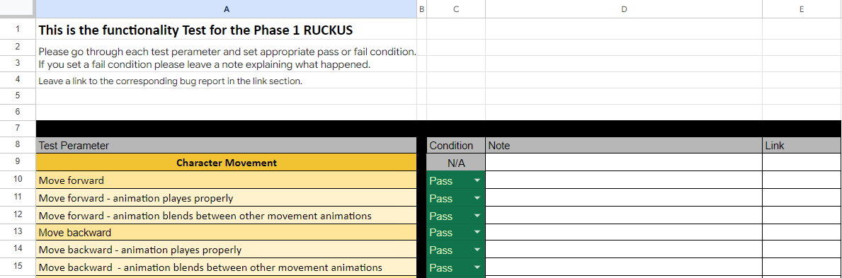

**Identification of Data Collected**

Data unanimously collected for each of the 4 levels is as follows: (This can also be expanded upon via the person assigned to the level.)

|  |
| --- |
| Can the player move?  Forward, Back, Left, Right  Can the player jump?  Vertical, Do they fall down?  Can the player light attack?  Can the player heavy attack?  Can the player sprint?  Stop sprinting  Can the player interact?  Does the player collide with the walls?  Does the player collide with enemies?  Can the player hit enemies?  Do multiple enemies spawn in?  Do multiple enemy types spawn in?  Can the enemies hit the player?  Can the enemies kill the player?  Can the environment kill the player? (If intended in the level)  Does the player take damage?  Can the player pick-up fuel?  Does the rage metre fill?  Can you activate rage metre?  Can the player regain health during the yellow health stage? (via attacking enemy)  Can the player access the shop?  Can they purchase items? Add augments? Remove augments? |

In addition to the excel forms for the 4 levels, there is also a table to fill out for bugs encountered during the different phases for each member.